1. 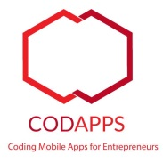If you don’t have one yet, you need first to create a free account with Codename One (the tool we use to create apps).

Level of difficulty:   
Estimated time: 15 mn

[**www.codapps.io**](http://www.codapps.io)by Clement Levallois **@codapps_io** [**www.coursera.org/learn/codapps**](http://www.coursera.org/learn/codapps)



**Module 4: Testing your app on a phone and distributing it**

*How to publish your app on Google’s Play Store*

To do so, visit their website at [www.codenameone.com](http://www.codenameone.com) and select “Sign up”.

Choose the free version. You are not obliged to choose to receive the newsletter.

Please open the confirmation email you will receive and click on the link in it to confirm the creation of your account.

1. You also need to create a “Google Play Developer account”. That sounds fancy, but this is just something you can get here:

<https://play.google.com/apps/publish/signup/>

**Note! This account allows you to publish as many apps as you want for Android phones, without limit of time. The account costsa one time fee of 25$.**

When you have created this Google Play Developer account,

1. In NetBeans, right click on the name of your project and select “Properties”

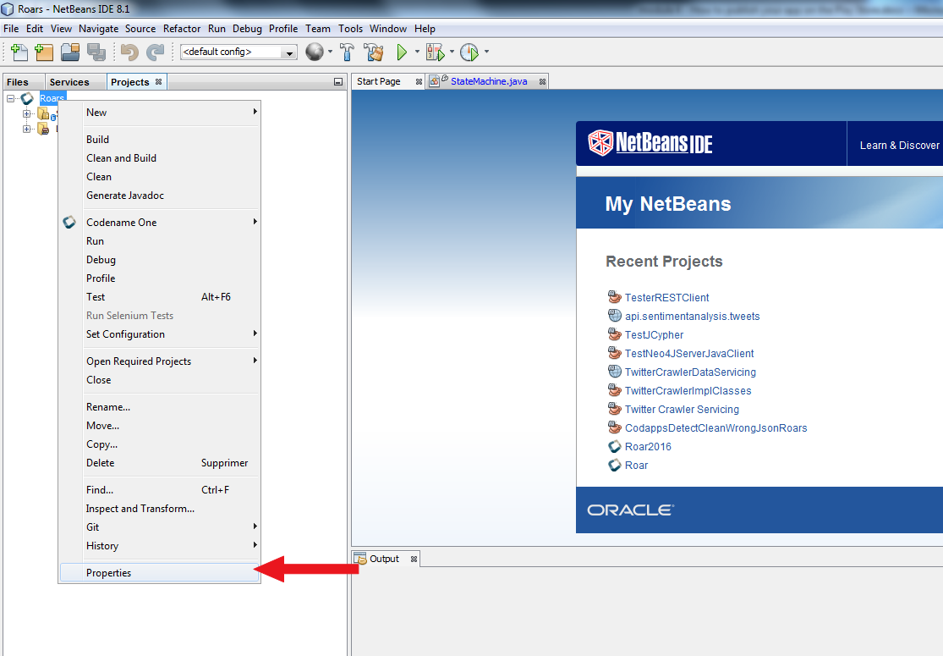

1. n the menu that opens, follow these 3 steps:

Level of difficulty:   
Estimated time: 15 mn

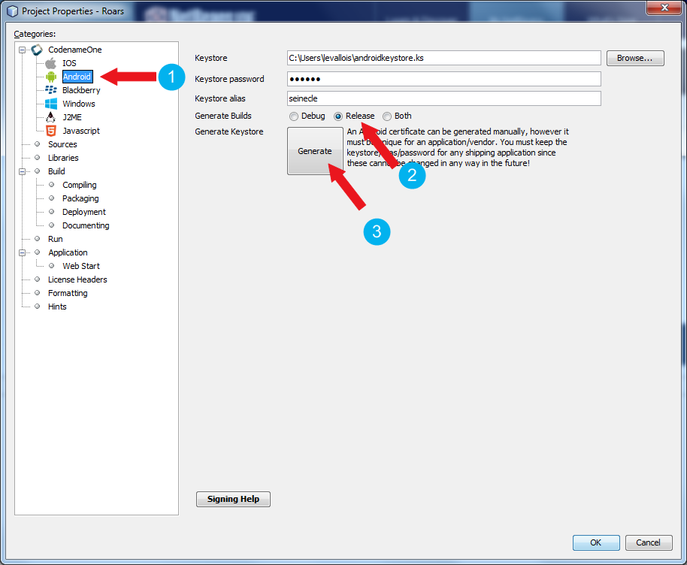

1. Click on “Android”
2. Make sure “release” is selected
3. Click on “Generate”. This opens a new window, follow the steps below:

**Module 4: Testing your app on a phone and distributing it**

*How to publish your app on Google’s Play Store*

[**www.codapps.io**](http://www.codapps.io)by Clement Levallois **@codapps_io** [**www.coursera.org/learn/codapps**](http://www.coursera.org/learn/codapps)



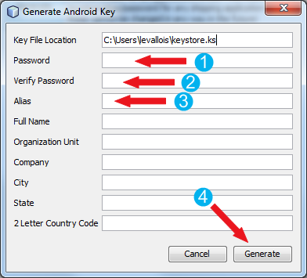

Level of difficulty:   
Estimated time: 15 mn

**Module 4: Testing your app on a phone and distributing it**

*How to publish your app on Google’s Play Store*

[**www.codapps.io**](http://www.codapps.io)by Clement Levallois **@codapps_io** [**www.coursera.org/learn/codapps**](http://www.coursera.org/learn/codapps)



1. Choose a password without fancy character (just letters, no spaces)
2. Repeat the same password
3. Choose an alias. Again, I advise for something simple: just letters, no spaces.
4. Click on “Generate”
5. You are back to the previous window. Click on “OK”. You can now send your Android build to Codename One, which will create an APK file you can upload to your Google Developer account here: <https://play.google.com/apps/publish>

**You should have no error about “APK being in debug mode”. If you still have one**; it might be because you previously created a certificate for debugging, not for publishing. To erase it and use the correct certificate, redo the steps of this tutorial, making sure you choose “release”’ in step 4). Then, in step 5, in the window “Generate Android Key”, change the name of the keystore. Instead of “keystore.ks”, right “keystore2.ks”. This will make sure the app uses this newly generated certificate, not the old one valid just for debug.